Maintaining and strengthening well-being:
a regular starter activity for students to ‘work on well-being’

Teacher notes:
- This activity is aimed at years 7-11, depending on learners’ needs and allows learners to begin their health education lesson with a routine, with their own input, that links to their personal well-being.

- The activity was developed by Alex Aitken: Hornby High School, with support from Debbie Jones, NZHEA kaiārahi. Alex uses this activity with her year 9 & 10 students and reports:
“The kids love it. Every single class has requested that it’s repeated for the remainder of the year. We are at the point now where the students have personalised the tasks to improve their own wellbeing rather than my ideas. It’s a great way to connect with every student before you begin teaching and it makes for a good routine.”

- Adapt to suit your learners’ needs. The activity that follows is written with students as the audience – adapt the ideas, language and health models to suit. For example, students might have created their own model of well-being, which they can use to reflect upon.

- An optional follow-on activity would be to develop a visual display of students’ actions and reflections (for example on the classroom wall or digitally) – this might support less confident students with their ideas. Learners could also write up their experiences of undertaking this over a period of time for a variety of purposes. Further writing prompts could also be provided for students who find it difficult to express their ideas in writing, or they could record their reflections through voice recording or video logs.

Student activity – working on my well-being

Te whare tapa whā is a way of looking at a person’s health from four sides: taha tinana (physical), taha hinengaro (mental & emotional), taha whānau (social) and taha wairua (spiritual).  Image is from: http://health.tki.org.nz/Teaching-in-HPE/Health-and-PE-in-the-NZC/Health-and-PE-in-the-NZC-1999/Underlying-concepts/Well-being-hauora | The five ways to well-being is a model adopted by the Mental Health Foundation of NZ as a way of taking steps towards looking after our own (and others’ well-being). The website from which this image was sourced actually adds another three ideas to this list – check them out at: https://econation.co.nz/the-8-ways-to-well-being/

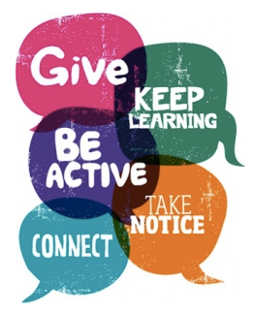
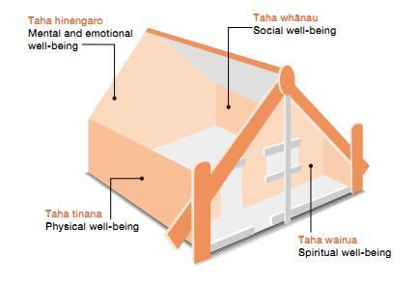

To be able to maintain good health it is important to work out what we need at different times of life. If we can recognise what it is that is causing us not to be able to “feel good and function well”, then we can make change.

Making change can be hard. It is important to be able to take time out to reflect and try to work out ways to build or strengthen our well-being. This will allow us to have a change in perspective around things and lead to positive mindsets and attitudes. Each of us is different, therefore need more of some things, and less of others. Understanding this helps us to enhance our own and others’ well-being.

Two popular models used in New Zealand to think about health and well-being are Te Whare Tapa Whā and the 5WTWB. Te Whare Tapa Whā is a focus in our health education curriculum, however you may have heard of 5WTWB.

How we will work towards strengthening and maintaining well-being:
- At the beginning of each class up to 10 minutess will be given for you to work towards well-being. For this to work we have to be mindful of others so need to carry out these tasks quietly and respectfully.
- Pick a task from the grid below that you think is important for you to work towards.

- At the end of the 10 minutes shade the box you chose to focus on to show that you have completed it.

- An action/ task can only be completed once in a week.

- Log in your learning journal what it is you have done and what dimension of well-being (Te Whare Tapa Whā) or aspect of 5WTWB you think it connected with. Explain why.
Choice of actions/tasks to strengthen well-being

Learn something new | 10 minutes free play/time | 10 minutes of reading | Complete something that you need to get done, prioritise
10 minutes listening to music, chill | Make a thank you card to express your gratitude to someone you care about | Connect with someone and have a chat quietly with them | List five things that you are grateful for and explain why
10 minutes picking up rubbish - care for your environment | Write down three meaningful compliments to give to special people to show you care about them | 10 minutes of rest | Notice what's happening around you using your five senses, sit and do nothing
My own idea/ choice | Make something | Colour in something or design something | Sit down and breathe, use an app to do some breathing
Write down something about yourself that you feel proud about | Find an event or explore an event that you want to do find out more about | Ask a friend for some help | Give a friend some help with something
Stretch in every direction | Write down the things that are going well for you right now | Write down three things you are looking forward to | My own choice/idea

Strengthening my well-being log
How I feel before choosing action (mark on continuum (1) = blah and (5) = ready to rock  1 _______________________________ 5 |  | How I feel AFTER the action (mark on the continuum (1) = blah and (5) = ready to rock  1 _______________________________ 5
Date: | Action chosen: | Dimension or action from 5WTWB (or both): | Why it connected?
How I feel before choosing action (mark on continuum (1) = blah and (5) = ready to rock  1 _______________________________ 5 |  | How I feel AFTER the action (mark on the continuum (1) = blah and (5) = ready to rock  1 _______________________________ 5
Date | Action chosen | Dimension or action from 5WTWB (or both) | Why it connected?
How I feel before choosing action (mark on continuum (1) = blah and (5) = ready to rock  1 _______________________________ 5 |  | How I feel AFTER the action (mark on the continuum (1) = blah and (5) = ready to rock  1 _______________________________ 5
Date | Action chosen | Dimension or action from 5WTWB (or both) | Why it connected?
How I feel before choosing action (mark on continuum (1) = blah and (5) = ready to rock  1 _______________________________ 5 |  | How I feel AFTER the action (mark on the continuum (1) = blah and (5) = ready to rock  1 _______________________________ 5
Date | Action chosen | Dimension or action from 5WTWB (or both) | Why it connected?

