Making connections with Pacific ideas in health education

COPY TEMPLATES
for the activities

A resource to support teaching and learning in
The New Zealand Curriculum

Gloria Tu’itupou, Kata O’Donnell, & Jenny Robertson

Making connections with Pacific ideas in health education: A resource to support teaching and learning in The New Zealand Curriculum (2020) by Gloria Tu’itupou, Kata O’Donnell, and Jenny Robertson

NZHEA 2020

© NZHEA (activities)
© Jenny Robertson, Kata O’Donnell (activities)
© Gloria Tu’itupou (HPE Scholarship report)
ISBN 978-0-473-52985-7

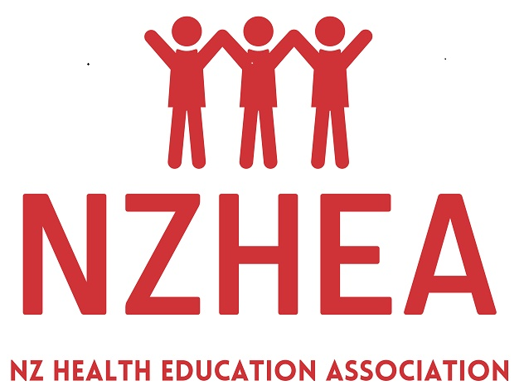

New Zealand Health Education Association (NZHEA)
PO Box 63, Lyttelton 8841, New Zealand
Email admin@healtheducation.org.nz

Website link for this resource
https://healtheducation.org.nz/resources

This Word document contains only the Resource sheets and Copy templates from the resource. Teachers may copy and/or adapt these for use, either as print materials or digitally. Please see the full text for details of these activities.

Recommended citation
Tu’itupou, G., O’Donnell, K., & Robertson J. (2020). Making connections with Pacific ideas in health education: A resource to support teaching and learning in The New Zealand Curriculum. New Zealand: NZHEA.

Contents

Note that note all of activities have a resource sheet or Copy template.
Part 2 Teaching and learning activities for years 9&10
2. My model of wellbeing
3. My ‘tapa’ cloth
4. Pasifika Success Compass – thinking about what success means to me
5. Wellbeing and the PolyFest
9. Talanoa – dialogue and wellbeing
10. Learning across the generations
11. Navigating different worlds … and what happens when these worlds collide?
12. Being true to ourselves
13. Interconnections
14. Traditions and wellbeing
16. Sayings and songs
18. Cultural appreciation or appropriation?
19. ‘We belong here’ – visual cultural artefacts in the community
20. Planning for community action – restoring the traditional lei
21. Food ….. for thought
22. Wellbeing and the environment

Activity 2. My model of wellbeing

Ideas for dimensions of wellbeing for own model

Physical wellbeing – food, sun, water, hygiene, exercise, sleep, well (as in not sick), clean air, safe clean homes and places to live and play, recreation, sport …….

Social – family, friends, support, love, care, community, safe neighbourhood, going to school (education), respect, humility, fairness, inclusive, play, games …..

Mental and Emotional (thoughts and feelings) – content, happy, in control, confident, valued, wanted, fun, coping, knowing (having knowledge), knowing what to do, knowing my ancestry or history, wisdom ……

Spiritual – connected, belonging, interests (named e.g. sports, arts and culture, hobbies, experiences), identity (knowing who I am), environment, sexuality and gender identity, cultural identity, hopes and dreams, language, sense of direction or purpose, independence or autonomy, power, balance, connections between mind and body, time and place …..

What other ‘dimensions’ could be added or used as alternatives?

Activity 3. My ‘tapa’ cloth
Spiritual wellbeing - “the deep stuff”
What are three customs that are a part of your culture?  1.  2.  3. | What are five things that are really important to you?  1.  2.  3.  4.  5. | Identify 4 things that make up who you are.  1.  2.  3.  4. | Do you or a friend have faith in something? If so, what do you/your friend believe in? | Identify 3 things you believe.  1.  2.  3.
These are often called cultural practices. | These are what you value. | This is a part of your personal identity. | This could be part of their religion. | These are your beliefs.
What’s one thing you have learnt about yourself so far this year? | What are you passionate about? Identify 3 careers this could lead to.  1)  2)  3) | When did you last achieve or win something? What was it? | What three activities increase your confidence? | Based on some of these ideas I can say that, for me, spiritual wellbeing is about:
This contributes to developing your self-awareness. | These could contribute to your purpose in life. | You may have felt a sense of achievement during/after it. | These help boost your self-esteem/self-worth.

Tapa cloth knowledge race | Your answers
Where in the Pacific does the name ‘tapa’ come from?

Give the name of ‘tapa’ cloth in three other Pacific languages.
What is tapa cloth made from?

What is the basic technique for making tapa cloth?

Who in Pacific communities makes tapa cloth?

What is tapa cloth used for?

What sorts of images are painted on tapa cloth?

How are the images similar or different for some Pacific island nations?
Can you identify one place in your school where a tapa cloth artefact is on display?
Name someone who has a tapa cloth artefact in their home (if no one in your group, you will need to try and find someone else in your class).
OR see if you can find a photo of someone famous or someone in your community being photographed with something made of tapa cloth – at their workplace, in a gallery, or at an event.
What is one other interesting thing you found out about tapa cloth – why was this interesting?

Activity 4. Pasifika Success Compass – thinking about what success means to me

Personal reflection about success
Use ideas from the Pasifika Success Compass, as well as your own ideas, when thinking about and answering these questions. What helps you be successful can be about life with your parents and families, what you do in your community, as well as what goes on while you are at school.

- Participation: Pacific children start school well prepared for education success. | Thinking about your early childhood:  What memories of success do you have from the time you were at primary school?  If you can’t think of any, why do you think this is the case?
- Engagement: Personalising learning and creating successful pathways for learners across their education journeys | Thinking about your successes since you’ve been at high school:  In what ways have you been successful since you’ve been at high school? Think of things besides just school work.  In what way has one of your teachers, or one of the school leaders, helped you to be successful at something this year?  I am currently in year ___. I plan to leave school at the end of year ___.  What is one thing the school will need to help you with to make sure you make good decisions about your learning pathway (that is, the courses you take while you are at school and other ways you will be involved at school)?
- Achievement: Pacific school leavers are academically and socially equipped to achieve their goals | Thinking about your future while you are still at school:  Imagine that you are 17 or 18 years old, you have achieved NCEA level 2 or 3, and you are ready to start the course of your choice at polytech, university or elsewhere.  Identify 3 things that your school needs to do to ensure that you are ‘academically equipped’ (that is that you have learned everything you need to be successful in your studies or training after you leave school).  Identify 3 things that your school needs to do to ensure that you are ‘socially equipped’ (that is that you have a range of self-management and interpersonal skills, and knowledge of what to do and how to behave, in a range of situations).
Your future | Thinking about your future beyond school:  Try to imagine your life in 10 years – if you have been successful, what will your life look like?  What about 20-30 years (think about how old you will be then and what you would like to have achieved)?  How would you describe your wellbeing as a result of these successes?

Activity 5. Wellbeing and the PolyFest

Physical wellbeing - Taha tinana | Mental and emotional wellbeing - Taha hinengaro
Before:  During:  After: | Before:  During:  After:
Social wellbeing - Taha whānau | Spiritual wellbeing - Taha wairua
Before:  During:  After: | Before:  During:  After:

Activity 9. Talanoa – dialogue and wellbeing

United Nations Climate Change 2018 Talanoa Dialogue Platform

"Talanoa is a traditional word used in Fiji and across the Pacific to reflect a process of inclusive, participatory and transparent dialogue. The purpose of Talanoa is to share stories, build empathy and to make wise decisions for the collective good. The process of Talanoa involves the sharing of ideas, skills and experience through storytelling.
During the process, participants build trust and advance knowledge through empathy and understanding. Blaming others and making critical observations are inconsistent with building mutual trust and respect, and therefore inconsistent with the Talanoa concept. Talanoa fosters stability and inclusiveness in dialogue, by creating a safe space that embraces mutual respect for a platform for decision making for a greater good.”

Source: https://unfccc.int/process-and-meetings/the-paris-agreement/the-paris-agreement/2018-talanoa-dialogue-platform

Timote M. Vaioleti - Talanoa research methodology: a developing position on Pacific research
… I argue that Talanoa,' "a personal encounter where people story their issues, their realities and aspirations" (Vaioleti, 1999-2003), allows more mo'oni (pure, real, authentic) information to be available for Pacific research than data derived from other research methods. I argue, using the metaphor of tui kakala (Helu-Thaman, 1997), that a cultural synthesis of the information, stories, emotions and theorising made available by Talanoa will produce relevant knowledge and possibilities for addressing Pacific issues. (p21)
Source: Waikato Journal of Education 12:2006 https://pdfs.semanticscholar.org/e36e/3e41b72228b1bf358238131309232c5efba9.pdf

The Tongan concept ‘fofola e fala ka e talanoa e kāinga’ means the laying out of the mat for families to talanoa. This provides a space that empowers every member of the family because on the ‘fala’ or mat everyone is equal.

The Talanoa model
From Togi Lemanu, CORE Education
‘The word ‘talanoa’ is a term meaning to talk or speak. The four elements around the word ‘talanoa’ are attributes that make the ‘talanoa’ more meaningful and rich. They are Tongan words with similar meanings used in other Pasifika languages.’
Source: http://blog.core-ed.org/blog/2014/12/creating-the-talanoa-conversation-is-all-it-takes.html
Ofa/Love | ‘When we talanoa with our Pacific parents, families, and communities, we start with questions about ourselves’ – who am I, who are you?
Mafana/Warmth | ‘Throughout the ‘talanoa’ the conversation is warm and not threatening to both parties … it’s more of a heart-to-heart’.
Malie/Humour | ‘The talanoa needs to have a bit of humour in order for the conversation to be real.’
Faka’apa’apa/Respect | Respect is woven throughout the four elements.

Activity 10. Learning across the generations

Conversation guide | My script or ideas about what I want to say and what I would like to ask
Introduction
- How I will introduce myself
How I will ask the person I am interviewing to say something about themselves
- How I will explain what the conversation is about – making sure the ‘wellbeing’ purpose is clear
- How I will explain why I am asking the person to have a conversation with me and what I need the information for.
- How I will check with the person I am interviewing that they are OK about this and if they have any questions.
The conversation
- What I need to explain to the person so they can learn something from me (and get them to ask me questions).
- Questions I want to ask so I can learn something from the person.
- A question I need to ask to find out what they learned from me.

Close
How I will close the conversation

Prompts (things you need to remember to do or not do)
- Effective listening ideas
- Talanoa ideas

Reflection questions after the conversation | My reflection
The adult I had a conversation with was ….
What did you learn from the adult?
What did they learn from you?
What was the hardest or most challenging thing for you when having this conversation? Why did you find it challenging?
Did you somehow overcome this – and if so, how?
OR if not, what could you do differently next time?
What was the most valuable thing about this conversation?
Why was this valuable for you?

Overall, what has this activity taught you about having conversations with other people?

Activity 11. Navigating different worlds … and what happens when these worlds collide?

Excerpt (adapted) from Gloria’s report
Ease of Instant Gratification and Accessibility of Resources
Another determining factor that contributes to the difficulty of navigating Fetaulaki Vā, is ease. Time is a taonga. Hence, in a society where consumerism is ubiquitous, the ease of instant gratification is valued over learning and implementing time-consuming traditional practices. Amount of effort and time required for a task will therefore be a factor in the choice of cultural expression. Typically, quick and simple solutions prevail, modelled by the kahoa lole.
“Lolly lei are easy to make.”
In contrast, making Kahoa is a lengthy process, embodied in the stages of toli (gathering of kakala and lou’akau) and tui (making and weaving of kahoa). Toli involves specific and appropriate selection of matala’iakau (flowers). Picking, cutting and gathering evidently involves more labour in comparison to simply selecting one’s favourite chocolates off the store shelf. Tui varies in technique; some kahoa require the threading of each and every flower with greenery, while others can be weaved together. Working with such delicate materials further complicates the process. Time taken to fashion kahoa accordingly varies. Overall, such practices exemplify delayed gratification but are considered tiresome. Through the online talanoa, a student concurs:
“...I know how tedious the process is to be able to collect, clean and prepare the ti leaves and flowers,
Another student expressed,
“I feel like more effort is put into finding the right materials and the whole process is a bit more difficult”.
Accessibility as a consequence of geographic location and financial situation limits the availability of resources one has. This contributes to the navigation of Fetaulaki Vā because it influences the ability of one to culturally express themselves. For instance, when the materials that are commonly used in traditional practices are not readily available in A/NZ it means A/NZ fonua does not produce the same traditional kakala or lou’akau Pacific fonua does. Instead, the highly accessible artificial materials such as plastic and confectionery mean that A/NZ Pasifika communities are limited in their traditional cultural expression.
“We can't really access flowers for the traditional [kahoa].”
Rarity of kahoa and frequency of kahoa lole at special occasions demonstrate this.
“Nowadays, kahoa lole is mainly used in prize-giving, graduations, and sometimes birthdays because lole as materials to be used are easily accessed, edible and to be enjoyed.”
Financial accessibility due to economic influences also contributes to this navigation. Pasifika people have the lowest median income, and 56% of Pasifika people reside in deprived areas across A/NZ. Due to these financial circumstances, affordability contributes to choice of cultural expression. It is therefore understandable to see why cheap and convenient alternatives are utilised in creating the kahoa lole as opposed to traditional resources.

Glossary of Tongan and other terms used in this excerpt

Fetaulaki Vā - This symbolises when two ‘worlds’ encounter one another, and this space is yet to be effectively navigated.  Kahoa – lei or garland  Kahoa lole ‘lolly lei’  Matala’iakau - flowers | Taonga - Māori word for heirloom  Toli - gathering of kakala and lou’akau  - Kakala - klowers specific to kahoa  - Lou’akau - greenery (i.e leaves)  Tui - making and weaving of kahoa

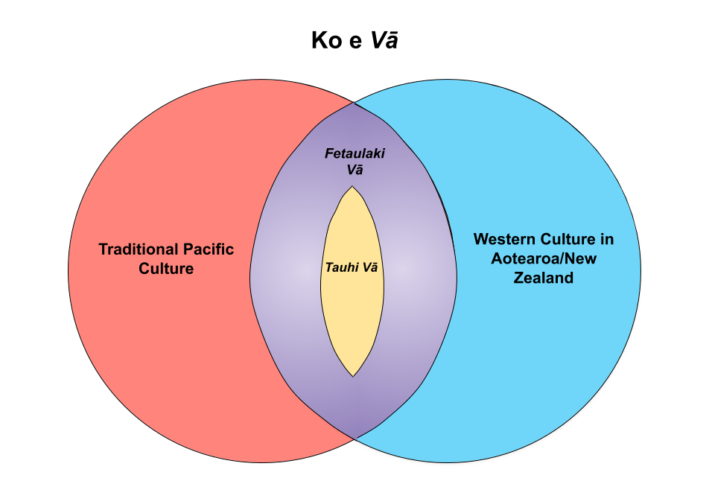
Gloria’s diagram shows some of the tensions between traditional Pacific culture and westernised culture in Aotearoa New Zealand.

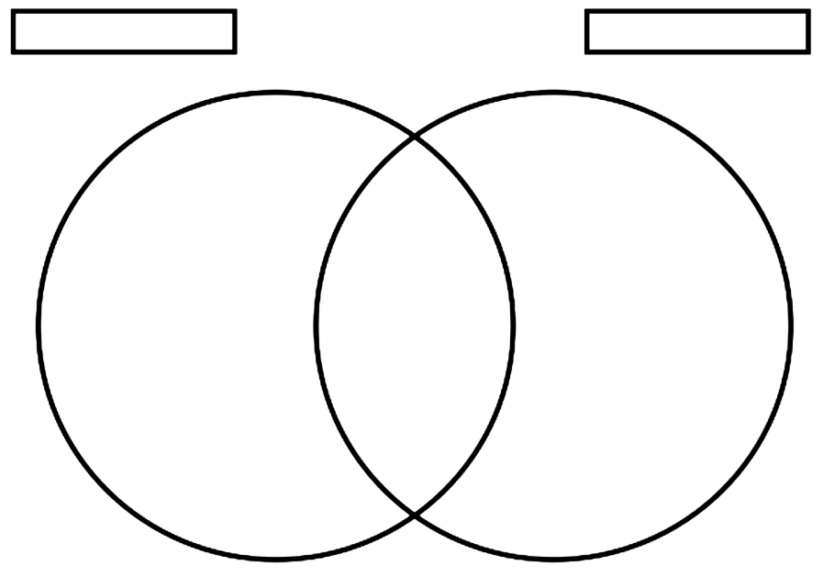

Activity 12. Being true to ourselves

Situation 1
Against their will and what they know is right, a student is pressured into shoplifting as an ‘initiation’ to be part of a group.

Q1. What does the person value or believe – what do they ‘hold true’:

Q2. How could this situation affect their wellbeing?

Q3. What knowledge and/or skills do they need to use to be true their beliefs?
Q4. How would using this knowledge or these skills affect their wellbeing in positive ways?

Situation 2
A student ignores another student being bullied and does nothing to help them, even though they know personally what’s it’s like to be bullied.

Q1. What does the person value or believe – what do they ‘hold true’:

Q2. How could this situation affect their wellbeing?

Q3. What knowledge and/or skills do they need to use to be true their beliefs?
Q4. How would using this knowledge or these skills affect their wellbeing in positive ways?

Situation 3
At a party a young person gives into pressure from their friends to drink alcohol and they end up getting drunk and in trouble. They had promised their parents that they wouldn’t have any alcohol.

Q1. What does the person value or believe – what do they ‘hold true’:

Q2. How could this situation affect their wellbeing?

Q3. What knowledge and/or skills do they need to use to be true their beliefs?
Q4. How would using this knowledge or these skills affect their wellbeing in positive ways?

Situation 4
A student who had been trying really hard to do well to get into a sports team/performance group misses out on a place. As a reaction to their disappointment they lash out in frustration at their family and friends, and, when they got even angrier after being told off for their behaviour, started smashing things.

Q1. What does the person value or believe – what do they ‘hold true’:

Q2. How could this situation affect their wellbeing?

Q3. What knowledge and/or skills do they need to use to be true their beliefs?
Q4. How would using this knowledge or these skills affect their wellbeing in positive ways?

Activity 13. Interconnections

Excerpt from Gloria’s report
“Traditional leis brings me back to my homeland, my roots. It reminds me of where I come from and not only myself but for others also, especially the person who makes them. They not only remember their homeland, their culture but we could also remember our family back in the islands and our ancestors. The lolly lei does remind me of my homeland but it's just not the same as the traditional lei.”
Statement provided during an interview

Activity 14. Traditions and wellbeing

Excerpt (1) from Gloria’s report
Cultural & Historical Significance of Kahoa

Kahoa has many names across the Pacific. Lei in Hawai’i, ‘ula in Sāmoa and ‘ei in the Cook Islands, the kahoa in its many forms is not only a symbol of cultural values but a reminder that all of the Pacific is connected. Polynesian culture is so intricately interwoven that it is difficult to pinpoint the exact origins of the kahoa. Arguably the tradition stemmed from Hawai’i, and was particularly popularised through Hawaiian tourism. Hence, kahoa is most notably known by its Hawaiian name, lei. While, the origins of the lei are complex, the meaning behind the garland is almost indisputable. Across the Pacific Ocean as well as the oceans of time, it has remained a symbol of ‘ofa, faka’apa’apa, fetokoni’aki, and pо̄lepole. Polynesian history shows lei was an accessory, represented status, and was also a token of appreciation and prestige, where the garlands would be used as offerings to God. The ‘lei’ is not so much a cultural article, but a cultural concept.

Kahoa is fundamentally linked to Pasifika fonua. Fonua, like the Māori word whenua, can be defined as land. Moreover it holds various meanings to the Tongan people and the Tongan culture. It is also the word for people, placenta and grave. We the people, receive sustenance from the placenta as children, receive sustenance from the land as growing individuals, and we therefore return to the land once we have reached the end of our lives. We the people, are inexplicably connected to the fonua. We the people, are the fonua. Fashioning kahoa using natural resources, such as kakala (flowers specific to kahoa), and lou’akau (greenery/leafy plants), kahoa becomes a tangible form of our most vital cultural values, centering land at its very core. Kahoa therefore holds distinguished cultural and spiritual significance. It deeply connects us to our fonua, ourselves, others and our fanga kui (ancestors) who came before us.

Prior to the turn of the century, kahoa were especially presented as a token of congratulations or recognition. Presenting a lei during celebrations such as graduations, prizegivings and milestones was a common custom in Pacific practices. Not only did it commend the receiver, but it also served as a representation of the immense pо̄lepole the bestowers of the lei felt. Today, it is less of a common sight to see kahoa in their traditional form. Over the last 20 years, kahoa has evolved into the modern interpretation, kahoa lole. Lollies and chocolates have replaced kakala, and plastic wrapping has replaced lou’akau. From one perspective, despite kahoa lole being constructed out of artificial materials, it has enabled A/NZ Pasifika people to recreate a traditional concept out of the resources readily available. It has given us the opportunity to ethnically and culturally express ourselves, especially in a once foreign fonua.

For many, the kahoa lole is an artform in its own right. Kahoa lole fashioning is complicated and is made with as much ‘ofa as a kahoa is. A contrasting perspective however, views the kahoa lole as an example of the struggle to navigate within Vā to a place where Pasifika well-being is enhanced. It can be further argued, that in trying to meld with Western society, we as Pasifika people have distorted our cultural traditions, disconnecting ourselves from one another, our fonua, and our fanga kui. This distortion is so complex, it has been integrated into Pasifika culture and society as an accepted normality.

Glossary of Tongan terms used in this excerpt

Faka’apa’apa - respect  Fanga kui – ancestors  Fetokoni’aki – support  Fonua – land  Kahoa – traditional garland or lei | Kakala - flowers specific to kahoa  Lou’akau - greenery/leafy plants  ‘Ofa – love  Pо̄lepole – pride

Excerpt (2) (adapted) from Gloria’s report

Presenting a lei as recognition of success

Kahoa lole, particularly in its mass amounts, attributes itself to the strong presence of familial values and shared cultural attitudes. The immense pо̄lepole (pride) and ‘ofa (love) one feels about their child, and thus their achievements, is cause for large scale commemoration. This is in spite of the expense of their personal time, energy and effort. Pasifika culture takes pride in celebrating in its excess. Interestingly, kahoa is rarely seen as being given and received in excess…

…Many associate the amount of kahoa lole (lolly lei) with the amount of success they have achieved, and therefore status they hold.

“I feel like have succeeded so much when I have a lot of lolly leis.”

The act of gifting for maintaining your reputation
Gifting gives the person receiving the gift (such as a lei) understanding that this act will be reciprocated (returned) in future. It is suggested that these acts of gifting help maintain a person’s reputation. An extravagant lei can become a display of status and prestige rather than honour its traditional meaning.
“It sometimes feels like families are competing to show off how much lolly necklaces they can get on their child rather than focusing on congratulating them.”

Accessibility of Resources
Time is a taonga (a treasure). The amount of effort and time required for a task will therefore be a factor in the choice of cultural expression. The kahoa lole offer a quick and simple solution.
“Lolly lei are easy to make.”
In contrast, making kahoa is a lengthy process, to gather the flowers, and greenery and then make the kahoa. Picking, cutting and gathering involves more labour to simply selecting one’s favourite chocolates off the store shelf. Tui (making kahoa) varies in technique - some kahoa require the threading of each and every flower with greenery, while others can be woven together. Working with such delicate materials further complicates the process.
“...I know how tedious the process is to be able to collect, clean and prepare the ti leaves and flowers.”
“I feel like more effort is put into finding the right materials and the whole process is a bit more difficult”.
Accessibility to resources influences the ability of one to culturally express themselves. When the materials that are commonly used in traditional practices are not readily available in Aotearoa/New Zealand (A/NZ) it means fonua the land) does not produce the same traditional kakala (flowers) or lou’akau (greenery) as Pacific fonua does. Instead, the highly accessible artificial materials such as plastic and confectionery mean that A/NZ Pasifika communities are limited in their traditional cultural expression.
“We can't really access flowers for the traditional [kahoa].”
“Nowadays, kahoa lole is mainly used in prize-giving, graduations, and sometimes birthdays because lole as materials to be used are easily accessed, edible and to be enjoyed.”

Changing Traditions
The kahoa or lei
What would be the ‘pluses’ of keeping with the traditional kahoa or leis? | What would be the ‘pluses’ of keeping the modern kahoa lole or lolly leis?
What would be the ‘minuses’ of keeping the traditional kahoa or leis? | What would be the ‘minuses’ of keeping the modern kahoa lole or lolly leis?
What other ‘interesting’ or informative comments would you make about the traditional kahoa (lei) and/or the modern lolly lei?

Another cultural tradition that has changed over time

What is the tradition? | How has it changed?
Why do you think the tradition has changed?

What would be the ‘pluses’ of keeping with the tradition? | What would be the ‘pluses’ of keeping the modern way?
What would be the ‘minuses’ of keeping the tradition? | What would be the ‘minuses’ of keeping the modern way?
What other ‘interesting’ or informative comments would you make about the traditional and/or the modern way?

Activity 16. Sayings and songs

Excerpt from Gloria’s Scholarship report (adapted)
“Vale ‘ia tama,” is a Tongan proverb literally translating to ‘foolish about a child’.
It portrays a mother’s vast and passionate ‘ofa (love) expressed through working tirelessly for her tama. Thereby losing sight of when to stop, she will spare no expense for her children.
While this cultural attitude can prove to be detrimental for the health and well-being of the mother and tama, in the many cultures of the Pacific, sacrifice and humility are integral values. Lack of questioning our actions even when they are inadvertently harming us is therefore an issue.
The immense pо̄lepole (pride) and ‘ofa (love) one feels about their child, and thus their achievements, is cause for large scale commemoration.
This is in spite of the expense of their personal time, energy and effort. Pasifika culture takes pride in celebrating in its excess. Interestingly, kahoa (lei) is rarely seen as being given and received in excess.

Proverb or saying in Pacific language and English:
Where is it from?
Further explanation of its use and meaning (if applicable):
Why did you choose this proverb or saying?
How might a person use this saying (what meaning might they take from it) that would support their wellbeing?

Traditional song title:
Lyrics (words):
Why did you choose this song?
How might a person use this song that would support their wellbeing? (e.g. what meaning might they take from it; is there an association with where and when it is sung; is there something about the melody/the tune?)

Modern song title:
Singer:
Lyrics (words):
Why did you choose this song?
How might a person use this song that would support their wellbeing? (e.g. what meaning might they take from it; is there an association with where and when it is sung; is there something about the melody/the tune?)

Summary:
What similarities and differences can you see among your responses to the questions?
Do you think you use proverbs and songs to support your wellbeing is similar or different ways? Explain your answer.

Activity 18. Cultural appreciation or appropriation?

Cultural artefact or image | Situation | Do you think is it a case of cultural appropriation? Why or why not? Think of who is advantaged (benefits) who is disadvantaged (offended or harmed in some way). | How could this situation impact the wellbeing of the people that the cultural symbols or artefacts originated with?
Māori ta moko (tattoo) on the face of men or moko kauae (chin tattoo) on Māori women | Non-Maori with facial tattoos using obvious Māori designs
Traditional body tattoos using Māori designs | Non-Maori with body tattoos using obvious Māori designs
Traditional body tattoos using Pacific designs (as worn by a chief or warrior) | Non-Pasifika people with body tattoos using obvious Pasifika designs
Hijab (head, face, or body covering ) worn by Muslim women | Fashion models wearing hijab as a fashion accessory for a runway show or a fashion magazine photo shoot
Bindi (coloured dot on the forehead) worn by Indian women | People at music festivals wearing bindi and other Indian cultural symbols
Skin colour associated with ethnic groups | A non-Māori/non-Pacific/non-African (etc) person paints their face and other skin brown or black to dress up as or ‘perform’ like a person from another ethnic background.
African dreadlocks or plaited cornrows | Non-African people wearing dreadlocks or cornrows
First nations or Native North American feather headdresses | People wearing native American costumes, including feathered headdresses, to dress up for costume or fancy-dress parties
Pacific imagery (such as flower motifs) | Use of Pacific patterns and motifs as designs for a range of decorative products
Māori imagery incorporating the koru or unfurling fern frond, as used in kowhaiwhai patterns | The koru on the tail of Air NZ planes and in many other forms of decoration
Religious symbols – Christian crosses for example | People wearing these symbols as fashion accessories
Wearing traditional dress e.g. Scottish tartan kilt, Indian sari, or Pacific island lavalava | People from other cultures wearing these forms of traditional dress
Tribal tattoos, scarring or piercings of some African cultures | People who use these techniques for aesthetic – or appearance only - reasons
Native American cultural images based on animal forms and beliefs associated with these | Using animals as mascots for American football and baseball games
Māori haka | Non-Māori performing a haka
Find more examples of your own

Activity 19. ‘We belong here’ – visual cultural artefacts in the community

Tūpuna Maunga o Tāmaki Makaurau Authority are seeking UNESCO world heritage status for Mangawhau and a range of preservation activities are underway.  These are photos of designs painted at various places on the summit road of Maungawhau (Mt Eden) in Auckland in 2019. The road is no longer open to vehicular traffic apart from service vehicles.  - Do you recognise the imagery used?  - Where else you can see patterns like this used?  - What do you think images like this are saying to tangata whenua (local Māori) and non-Māori New Zealanders? What do you think the message might be for the many overseas tourists who walk up the maunga?  - Why do you think Tūpuna Maunga o Tāmaki Makaurau Authority added these paintings to the road?  - What value do you think these add? Do you think they help people have a ‘sense of belonging’ in their community?  - How would you relate answers from these questions to wellbeing?  Source of explanations; The Māori Dictionary https://maoridictionary.co.nz/ and http://www.maori.org.nz/ | Poutama  The stepped pattern symbolises genealogies and the various levels of learning and intellectual achievement – these are positioned at the entry and exit to the road and at the crossroads of the road and walking tracks.  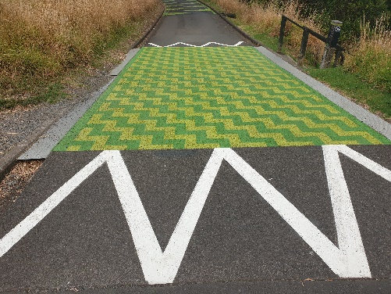  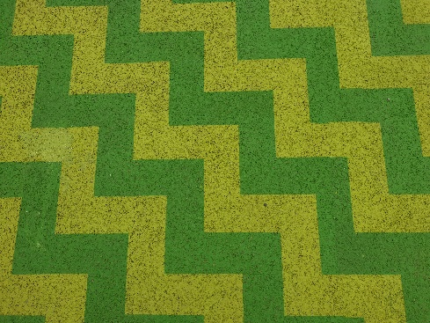  Pātiki (flounder) has several related meanings one of which is that it is a symbol of hospitality.  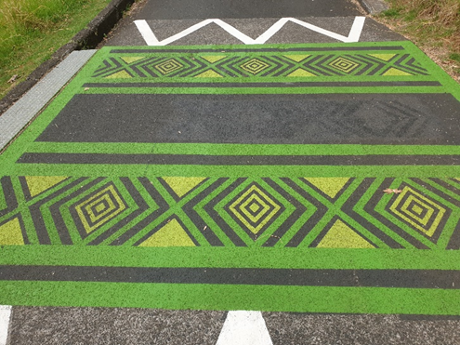
Niho taniwha (teeth of the taniwha) represents the realm of mythology and a chief's lineage from the gods. It also symbolises family houses within the tribe.

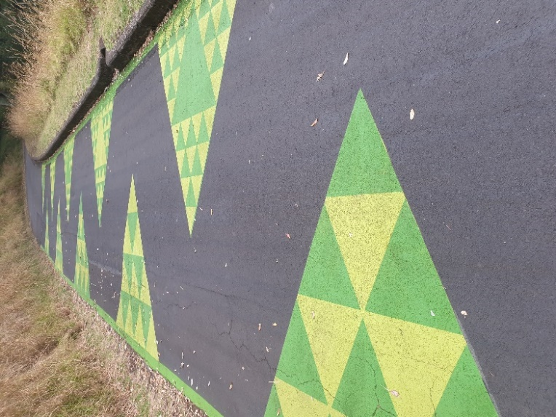
Activity 20. Planning for community action – restoring the traditional lei

Excerpt (adapted) from Gloria’s Scholarship report

… due to the cultural adjustment in the past 20 years, toulekeleka (elders) of Pacific people will witness the dwindling prevalence of traditional culture. Soon, they will not have any stake in cultural matters as perhaps it is not that traditions are becoming less valuable, but rather less relevant. On that account, toulekeleka (elders) are excluded from participating in Pacific society. Concerns about the lack of traditional knowledge within incoming generations of the Pacific will arise. Without traditional ideas, cultural adjustment will enforce a cycle of generations dependent on distorted values and unsustainable practices. As our grandparents and great-grandparents pass on, traditional knowledge die with them, disadvantaging the remaining and incoming generations. If knowledge about the cultural significance of kahoa has been lost or is being lost, what else is at risk? Presumably, lea fakafonua (language), faiva (arts), tau’olunga (dance) and anga fakafonua (the Pacific way).

Proposed action: promoting student and community wellbeing by replacing lolly leis with traditional leis
Prompts – what to think about and plan for if a school decided that:
- at this year’s prizegiving, all members of the school community would be asked not to give lolly leis (or leis that include food items, money and other such things), but instead
- all leis presented to students and staff/other adults needed to be made from flowers and/or plant materials and made in a traditional way.

For the sake of this activity, you can assume that:
- the action is being led by students AND that most students who have been asked think this is a good idea and agree with the reason for doing it; and
- you have several months of the year to do this leading up to prizegiving.

TASK: Make a big ‘map’ of all of the people who have to be informed, asked to do something different, helped to do something different, be asked to contribute knowledge or resources; what permissions and agreements need to be reached? And so on.

Actions …. | Prompts – use these questions to develop your own ideas – don’t be limited by these and add in more ideas or your own.
Involving school leaders and teachers | This is a student led action and you know you’ve got agreement from a lot of students to replace lolly lies with traditional ones at this year’s prizegiving. Before you start informing students and parents of our plans, you also need to get the school leaders (like the principal), the teachers, and the Board of Trustees (BoT) in agreement as well.  - How do you think you will go about informing the principal of your plan and negotiating how you will implement this (ie do all of the work outlined below)?  - What do you think you need to present to the BoT to make sure they support the idea?  - How do you think you will go about informing teachers and finding out how they can help?
Involving students | - How are you going to inform ALL students so they know what is expected of them? ie they are not expected to give lolly leis to their friends a prizegiving but instead it is expected they will give a traditional floral/plant lei?  - How will you ensure all students are ‘on board’ and agree with this?  - What are you going to do if some students disagree and say things like ‘this is ‘my’ culture, I’ll give lolly lei if want to’?  - How will you find out which students (and their parents/grandparents/other family members) already have the skills to make a traditional lei and how will you make use of these skills?  - How will you explain to students the support that will be available to them if they want to learn to make a traditional lei? What at-school activities and opportunities will there be to learn how to make a traditional lei?
Involving parents, grandparents and families | (Similar to above)  - How will you inform parents, get agreement, find out what skills they have that could be shared, notify them of the support they can get?  - What parent groups does your school have contact with and how can they help? E.g. think of the parent groups for different Pacific cultures.  - How will opportunities for learning how to make leis be advertised to parents and families?  - How will you ensure that responsibilities do not fall on only one or two families or community members who have the knowledge?
Involving other members of the community  … people with the skills to teach | - How will you find out who has the skills to make traditional leis and who would be prepared to teach students or parents and other family members? E.g. people at cultural centres or arts and crafts centres, etc.  - Who can carry out an online search to see if they can find community people to help?  - How are you going to get community people to help you e.g. providing a community (or school) venue and classes for teaching lei making for parents who want to learn (and who have the time to attend)?  - What are the opportunities (benefits) for some people?  - What are the possible unintended consequences of some of your actions?
…people with flower and plant resources | - Who has knowledge of NZ flowers and plants that could be substituted for those used in the Pacific Islands, especially when the flowers and plants that grow in the Pacific don’t grow here, or they are very expensive to buy?  - Is there a school or community garden that can be used as a source of some free plant materials?  - What guidance would need to be given when people are collecting plant materials e.g. not collecting from parks, or asking council/land owner if there is an area of plants that could be used?  - If flowers or plants need to be bought, what is an inexpensive source of these?  - If plants and flowers are (for some reason) not possible, what would be some acceptable flower and plant like alternatives? Who would have knowledge of this? Who would decide what a ‘suitable alternative’ could be? E.g. is a cheap ‘$2 shop’ artificial lei ‘good enough’? Think of the environmental sustainability issues.  - What are the opportunities (benefits) for some people?  - What are the possible unintended consequences of some of your actions?
… who else could be involved | - Who else in your school community can help the school achieve their goal e.g. promotion by church minsters, youth groups, cultural groups,  - Although PolyFest is held early in the year, what contacts could be made through this event where many traditional costumes (and the crafts to make these) are on show?

Activity 21. Food ….. for thought

Excerpt from Gloria’s Scholarship report

Reputation & Perception
Traditionally, food amount can be a display of a host’s faka’apa’apa (respect) toward guests. Inadequate amounts of food would therefore be considered a disservice and can reflect negatively on the host and their family. As a result, the attitude, ‘the more, the better’, is commonly adopted. Presenting mass amounts of food can uphold one’s reputation and accordingly their status. Particularly prevalent in Tonga which still holds a strict, complex and very traditional hierarchy displays of rank infer wealth and success and can therefore bode positive future outcomes.

Activity 22. Wellbeing and the environment

Consequences for the environment
Excerpt (adapted) from Gloria’s report
Essential for Pacific livelihood is fonua (land). Climate change, a current political issue, threatens the connections of our Pacific culture. It is a pressing problem for Pacific societies in that climate change is not only a political issue but an issue of survival. Rising sea levels leading to flooding, land erosion and sinking islands directly affects our Polynesian communities.
Developing Pacific Island countries only emit 0.03% of the world’s carbon dioxide emissions, and yet these regions of the world will suffer the worst effects of global warming and climate change. PI nations, including Tonga have already declared a climate crisis, expressing that lands could become uninhabitable as early as 2030 or optimistically 2050.
Evidently, the Pacific islands contribute a miniscule amount to climate change, however unintentionally, the sustenance of kahoa lole (lolly lei) in our cultural customs has contributed to the undermining of our Pacific fonua. Plastic wrap, cellophane, ribbons, and confectionery. All of these materials are manufactured by corporations and factories that are major contributors to greenhouse gas emissions, pollution and therefore climate change. Through mass purchase and waste, kahoa lole (lolly lei) essentially support and sustain those major businesses, undermining kāinga (community) and ‘atakai (environment) well-being.
A commonly held idea by Aotearoa/New Zealand (A/NZ) Pacific people is the insurance of always being able to return to the motherland. Tonga’s motto Ko e ‘Otua mo Tonga ko hoku Tofi’a, translating to ‘God and Tonga are my inheritance’, markedly speaks to this idea. Yet, if we continue to cultivate environmentally unsustainable practices, the Tongan truism will soon become an entirely metaphorical phrase. Eventually we will no longer have the fonua (land) of Tonga to inherit.
Overall, due to generational differences between to’utupu (youth), ngāhi matu’a (parents) and toulekeleka (elders), as well as the destruction of our planet, it is clear to see that disconnection is rife within the A/NZ Pacific society. Therefore social justice is not being upheld for all members of the Pasifika society. Generationally, this occurs in different ways.
Firstly, to’utupu (youth) experience a physical disconnection from the fonua (land). As climate change takes its toll on the planet, Pacific islands will eventually disappear. Fonua which sustained our fanga kui (ancestors) and our rich heritage and traditions will soon be enveloped by the ocean. A result of anthropogenic pollution, children of the Pacific will bear witness to the destruction of their fonua (alnd) and the severing of the physical connection to their roots. This disadvantages us because we are excluded from accessing an integral part of our Pasifika culture. We lose out on a vital cultural resource. Effectively, to’utupu (youth) will struggle to be active and productive participants of the Pasifika society because our sense of cultural identity is diminished.
Conversely, toulekeleka (elders) have a strong sense of cultural identity, due to an upbringing in the islands and a grounding in long-established values, practices and ideas. However, due to the cultural adjustment in the past 20 years, this generation of Pasifika people will witness the dwindling prevalence of traditional culture. Soon, they will not have any stake in cultural matters as perhaps it is not that traditions are becoming less valuable, but rather less relevant. On that account, toulekeleka (elders) are excluded from participating in Pasifika society.
Concerns about the lack of traditional knowledge within incoming generations of the Pacific will arise. Without traditional ideas, cultural adjustment will enforce a cycle of generations dependent on distorted values and unsustainable practices. As our grandparents and great-grandparents pass on, traditional knowledge die with them, disadvantaging the remaining and incoming generations. If knowledge about the cultural significance of kahoa (lei) has been lost or is being lost, what else is at risk? Presumably, lea fakafonua (language), faiva (arts), tau’olunga (dance) and anga fakafonua (the Pacific way).

NZHEA 2020

