In 2021, we have written exams for all externally-assessed Health Education standards. For AS 91235 (2.1) we have written two exams to provide different possible contexts.

This is the link to the 2021 folder of practice exams:
https://drive.google.com/drive/folders/1Fac2NfZa1TqJViSe7pfVCawofMtf3hpq?usp=sharing

There are two different options.

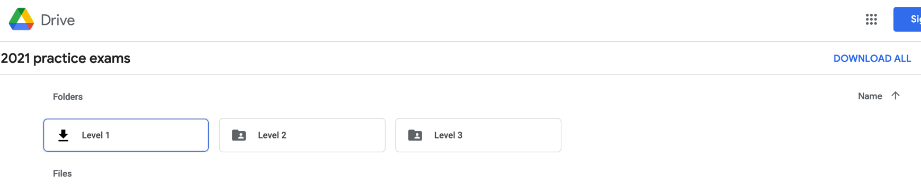
- If you open the link in a private browsing tab your page should look like this, and you can click on ‘download all’ over to the right of the screen to save all files to your computer at once:

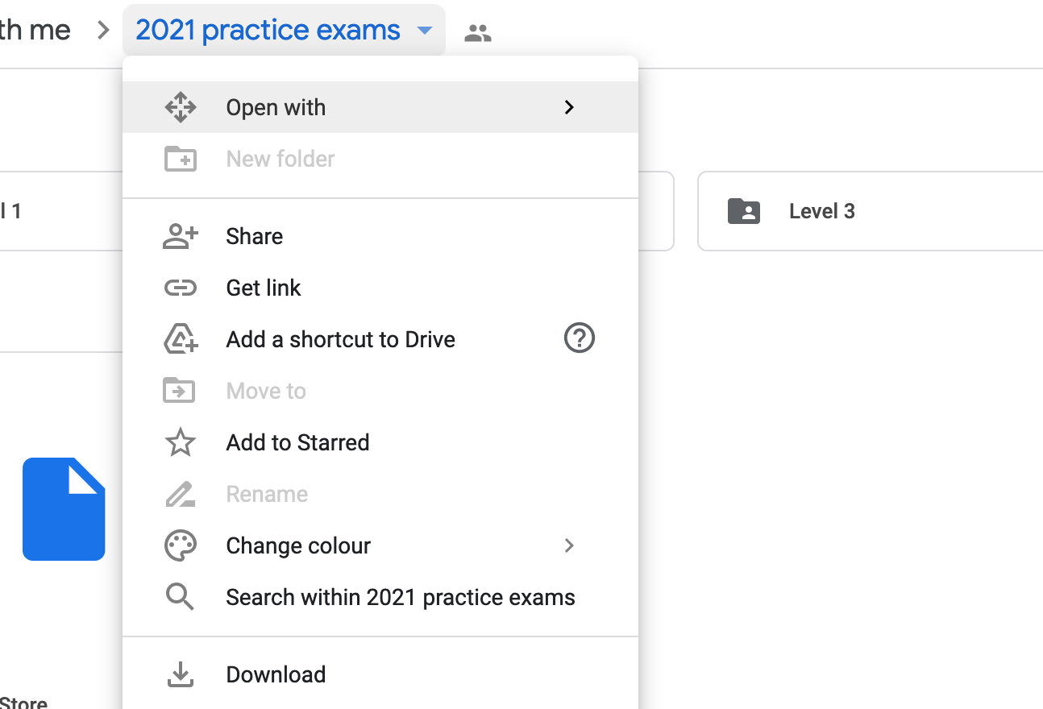
- If you open the link in a browser where you are signed in to Google Drive, you won’t see the ‘DOWNLOAD ALL’ button as above, but you can download them all using the drop down box from the folder title – as per below.

