Suggested activities for the August 2021 Accord days  Phase 2 NCEA Level 1 materials | 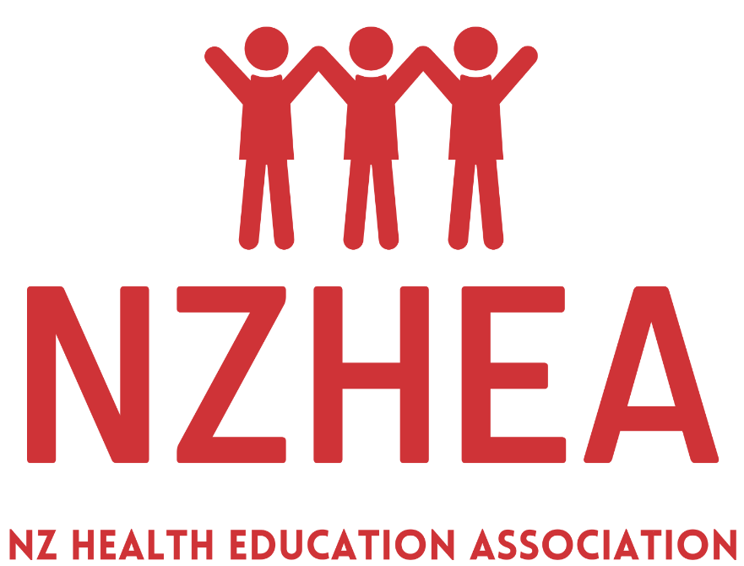

Navigation: Link to https://ncea.education.govt.nz/ …. Click on the ‘Subjects’ tab
Select Health Education (with Home Economics)
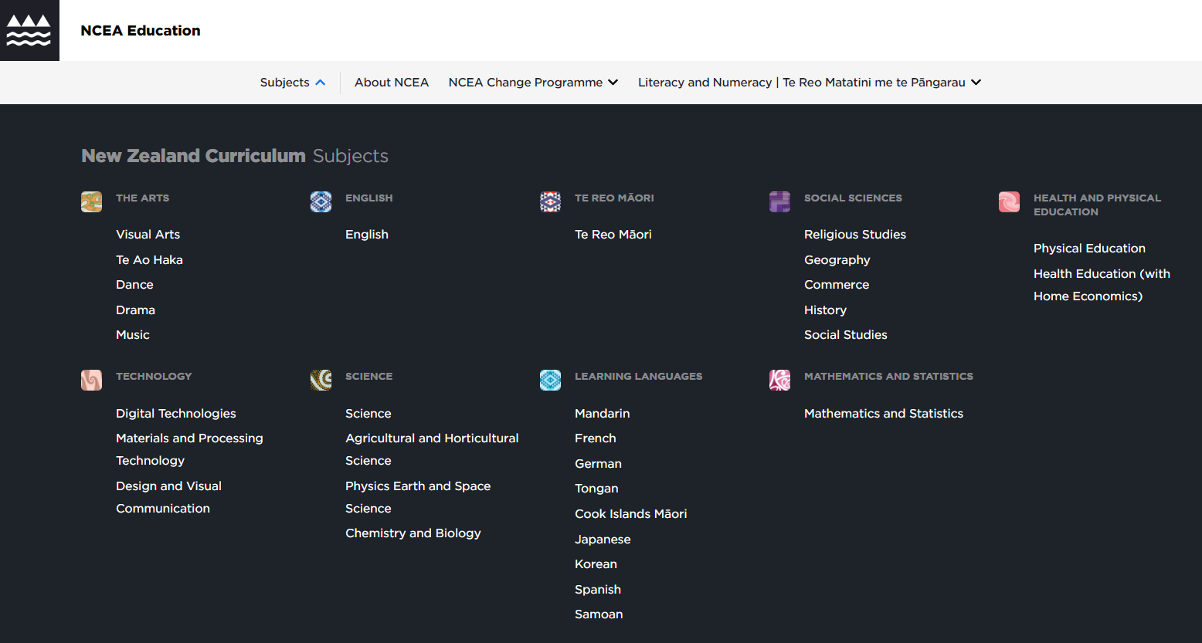
Use the tab across the top to navigate the various Phase 2 materials
If you haven’t already done so, add your voice to the proposed Level 2 and 3 subject list https://consultation.education.govt.nz/ncea/ncea-level-2-3-subject-list/

It is PROPOSED that:
L2&3 Health Education and Physical Education remain as subjects
Home Economics is reshaped and rebranded as Food and Nutrition

New subjects to be developed (think about the implications of this split NZC/TMoA decision ….)
- ‘Whaiora’ will sit under HPE in the NZC
- And a new subject ‘Hākinakina’ will sit under Hauora in Te Marautanga o Aotearoa

Learning | Discussion questions
BIG IDEAS – download the pdf that is the learning matrix.  - Not all of the BIG IDEAS are required to be assessed.  - See the additional text on this page unpacking the intent of these BIG IDEAS. | - Can you see that you can incorporate all of the big ideas into your learning programme in some way?  - Which big ideas are straightforward and already part of your learning programme, and …  - Which big ideas may present a greater challenge or require a different consideration to what you currently do?  - What (re)sources will you use to help develop these aspects of your learning programme?
Teaching
COURSE OUTLINES  Download (and maybe print) the 3 course outlines.  Do NOT be in any way limited by these course outline.  Note that the overall structure of these course outlines has been in consideration of those students who transition between schools. The risk with only 4 broadly focused standards is that assessment points occur less frequently across the year which may mean students changing schools miss assessment opportunities. If students in transition between schools is less of an issue for your community, this approach to course design becomes less important and frees up the way you can approach the design of a yearlong learning programme. | - To what extent would you say you currently ‘plan to the Achievement Standards”? [Be honest.]  - What will it take to shift the ‘teaching to the standards’ many of us are locked into, to think more in terms of designing a learning programme that is framed by your school’s local curriculum, in response to learner needs, and as a response to the direction provided by the NZC (and other education policy)?  - How can you see a Level 1 / year 11 HE(HE) programme being shaped in your school given the new ‘freedoms’ for the way you can design a learning programme? See the additional materials on the following pages.
Assessment
ACHIEVEMENT STANDARDS  PLUS  INTERNAL ASSESSMENT TASK ideas – with additional materials, including template for adapting these tasks.  It’s worth downloading all of the text into a single document to be able to sit the proposed standards and supporting materials (examples of tasks) side by side.  External assessments at this time are only an indication of the mode of assessment and timing in the year (no actual examples of assessments are provided).  Note that there is a recommended word limit on Level 1 learning and assessment artefacts and that’s 750-800 words or a 3-4 minute audio/video. | With the 4 standards in front of you, can you see:  - The ‘logic’ in what is here … given that HE(HE) is a consolidated subject? See the additional materials on the following pages explaining what we’re moving away from and moving toward.  - How each of the underlying concepts have in some way been ‘put on top’ for each standard (although the teaching in any context will cover all of the UCs), and ….  - That the evidence collected for assessment is a snapshot of the degree to which students have got the main idea of the standards (and we’re not reassessing the underlying concepts several times over across different contexts like we currently do).  - To what extent do the AME step ups make (initial) sense?  - To what extent do the Explanatory Notes add understanding of the criteria?  - To what extent do the sample assessment tasks illustrate the broad scope of what is possible with the internally assessed standards? How can you see you would adapt these for learners in your school?  - Externals: What are the implications for learning programme design if there is a mid-year CAA (Common Assessment Activity 1.3) and an end of year report (1.4)?
Mana ōrite mo te mātauranga Māori
See the NCEA change package statement now at https://ncea.education.govt.nz/change-2-equal-status-matauranga-maori-ncea | Thinking whole school curriculum and local community:  - What do you understand to be your school’s overall approach to engaging/consulting with whānau, hapū and iwi?  - And in particular, how does your school engage with whānau, hapū and iwi on curriculum design related matters? How does your HPE department connect with these wider school understandings and practices?  - Does your local iwi have an education plan with resources and/or personnel who can support schools develop their local curriculum?  - Given the sensitivity of some HE(HE) material and the ‘closeness’ of it to people’s personal experiences of the world and identity, as well as the often localised nature of the sort of knowledge we are interested in in this aspect of the curriculum, what conversations have you had (or do you need to have) with whānau and local iwi, around permission and authority to access and use such knowledge? At what point might you be deemed to be (mis)appropriating mātauranga Māori? What local meaning is given to the many mātauranga Māori ideas we might want to include in HE(HE) programmes? What knowledge (and interpretation of Māori knowledge) do whānau want their rangatahi taught?
… and considerations for the biennial health education community consultation
Remember that your health education programme – regardless of how it is included in the design of your school curriculum - must be consulted on every two years.  See https://www.tuturu.org.nz/healthconsultation/ | Thinking about the mātauranga Māori considerations above:  - What will be included in your delivery statement and programme overview (ie the material that is the basis for the consultation) about the way mātauranga Māori is to be included across your learning programme (including your NCEA Level 1 assessed course)?  - How will the consultation process be (culturally) responsive to whānau?

What we are moving away from …. Assessing the underlying concepts repeatedly across several prescribed contexts
Level 1 | Hauora | Socio-ecological perspective | Health Promotion | Attitudes and values
AS90971 1.1  Take action to enhance an aspect of personal well-being.  3 credits, Internal |  |  |  | ()
AS90972 1.2  Demonstrate understanding of influences on adolescent eating patterns to make health-enhancing recommendations.  4 credits, External |  |  |  | ()
AS91097 1.3  Demonstrate understanding of ways in which well-being can change and strategies to support well-being.  4 credits, Internal |  |  |  | ()
AS90973 1.4  Demonstrate understanding of interpersonal skills used to enhance relationships.  5 credits, Internal | () | () |  | ()
AS90974 1.5  Demonstrate understanding of strategies for promoting positive sexuality.  4 credits, Internal |  |  |  | ()
AS90975 1.6  Demonstrate understanding of issues to make health-enhancing decisions in drug-related situations.  4 credits, External |  |  |  | ()

What we are moving to ….. Assessing each UC once in a context selected by teachers and students
Proposed level 1 HE(HE) Standards | Mental health (includes AoD and all other MHEd topics) | Relationships and sexuality education (including gender) | Food and nutrition
1.1 Demonstrate understanding of Te Whare Tapa Whā in context  Emphasis on the underlying concept of hauora  5 credits internal | - You select the KAL context(s) for each standard  - Each underlying concept is assessed once (although the learning will naturally cover all UCs in a given ‘topic’ or unit).  - Mātauranga Māori is incorporated across learning programme and incorporated into assessment in ways that reflect local curriculum design and learner needs and input local whānau and from iwi.
1.2 Demonstrate understanding of an action to enhance hauora
Emphasis on the underlying concept of health promotion
5 credits internal
1.3 Demonstrate understanding of factors that influence a wellbeing issue
Emphasis on the underlying concept of the socio-ecological perspective
5 credits external
1.4 Demonstrate understanding of strategies that enhance hauora
Emphasis on the underlying concept of attitudes and values (in context of strategies for taking action to promote wellbeing)
5 credits external
Workshop task: Learning programme design
Health Education (with Home Economics) Level 1 NCEA
NZC HPE Underlying concepts | Hauora | Socioecological perspective |  | Health promotion |  | Attitudes and values
HE(HE) KALs from the HPE learning area | Mental health |  | (Relationships and) Sexuality Education |  | Food and nutrition
Mana ōrite mo te mātauranga Māori | Mātauranga Māori

What learning contexts (topics or themes) will you select from across the HE(HE) relevant KALs of the HPE learning area in the New Zealand Curriculum, leading to the assessment framed by the proposed HE(HE) standards? See template following.
- Base your learning programme on 32 weeks (~8 weeks of learning for each standard).
- Select contexts that have high relevance for students and which are topical in your school/community (as identified though student voice and other data), AND which reflect the priorities established in your local school curriculum.
- Think about exploring a range of different topics/contexts from within the broad intentions of the KALs, or across KALs, rather than one topic = one standard. Use the flexibility of the context/topic free standards to decide where and how you will develop understanding of the underlying concepts. Think also about the development of the HE(HE) big ideas across your course.
- Emphasise the development of the HPE underlying concepts (as they apply to HE(HE) and the transferability of these between contexts/topics). Think also about learning and qualifications pathways and how learning about the UCs at this level needs to be developed in preparation for Level 2 and 3 (assume the level or pitch of these UCs at L2&3 will remain much the same as present).
- Avoid designing a teaching and learning programme that simply teaches to the standards.
- Overall, consider opportunities for developing students’ critical thinking as well as the other key competencies, literacy skills (oral, written, visual), digital fluency and digital citizenship, cultural capabilities, inclusiveness of diversity, and student agency.
Also keep in mind ….. NCEA CHANGE PACKAGE 2. Mana ōrite mo te mātauranga Māori (~equal status for Māori knowledge)

Key changes
- Integrate te ao Māori and mātauranga Māori into the new ‘graduate profile’ for NCEA, and into the design of achievement standards.
- Ensure equal support for ākonga Māori in all settings, and equal status for mātauranga Māori.
- Develop more subjects to make sure that te ao Māori pathways are acknowledged and supported equally in NCEA (e.g. Māori Performing Arts).
- Ensuring that, where possible and appropriate, te ao Māori and mātauranga Māori are built into achievement standards for use across English and Māori-medium settings. That might mean:
- Having Māori-centred contexts for exemplars and assessment resources (e.g. local iwi history).
- Designing more inclusive standards and assessment resources that allow for diverse cultural perspectives on what’s important (e.g. considering community or hapū impact, not just individual user needs.
- Build teacher capability around culturally inclusive NCEA and assessment and aromatawai practice that is inclusive of ākonga Māori.

Mapping activity:
1.1 Demonstrate understanding of Te Whare Tapa Whā in context  Emphasis on the underlying concept of hauora  5 credits internal  Key Capability Making meaning | 1.2 Demonstrate understanding of an action to enhance hauora  Emphasis on the underlying concept of health promotion  5 credits internal  Key Capability Taking action
1.3 Demonstrate understanding of factors that influence a wellbeing issue  Emphasis on the underlying concept of the socio-ecological perspective  5 credits external  Key Capability Critical Inquiry | 1.4 Demonstrate understanding of strategies that enhance hauora  Emphasis on the underlying concept of attitudes and values (in context of strategies for taking action to promote wellbeing)  5 credits external  Key Capability perspective taking
The addition of the Key Capabilities here is more a ‘background’ understanding and was used for some initial framing of the standards to think about the various ways the standards would be different, and avoid reassessing the same ideas in a different way. If interested, more information about the key capabilities can be found in Coherent Pathways Guidance https://curriculumtool.education.govt.nz/en/Home/PathwaysGuidance/99200

Health Education (with Home Economics) Level 1 Course Outline: [Course title or theme]

Significant Learning | Learning activities and assessment opportunities | Duration  Total of 32 weeks
 | Course introduction | x weeks
 | Unit 1 | x weeks
 | Unit 2 | x weeks
 | Unit 3 | x weeks
 | Unit 4 | x weeks

Significant learning list for reference
- Explore hauora through Te Whare Tapa Whā and other holistic models of health and wellbeing, such as Fonofale
- Explore how mana and identity are connected with a sense of self-worth
- Explore Māori and Pacific knowledge bases, values and practices related to hauora and wellbeing
- Learn about how principles of fairness and inclusiveness can be applied to hauora and wellbeing approaches
- Learn about how kaitiakitanga, manaakitanga and whanaungatanga contribute to the hauora of individuals, whānau and communities
- Learn about a selection of food and nutrition, relationships and sexuality, and mental health contexts
- Understand personal and interpersonal skills that can enhance hauora
- Understand that hauora is more than a matter of personal choice and individual responsibility
- Understand that a variety of health-promotion actions are needed at personal, interpersonal, and societal levels to enhance hauora
- Understand diverse ways to manage change situations that impact hauora and wellbeing

FOR REFERENCE A LEVEL 1 ‘CONSOLIDATED SUBJECT’ of HEALTH EDUCATION WITH HOME ECONOMICS
He oranga ngākau, he pikinga waiora. Positive feelings in your heart will raise your sense of self-worth.
The health and physical education learning area statement opens with: “In health and physical education, the focus is on the well-being of the students themselves, of other people, and of society through learning in health-related and movement contexts.”
NZC, 2007, p22.
Four underlying and interdependent concepts are at the heart of this learning area:

Hauora | The socio-ecological perspective |  | Attitudes and values |  | Health promotion
Health Education and Home Economic draw from the following Key Areas of learning (KALs).
The KALs cover many subject specific health and wellbeing-related contexts or topics. The underlying concepts above are applied in combination to shape teaching and learning about these contexts. The underlying concepts are used to explore:
- How the topic is a health and wellbeing matter through the evidence-based ways it relates to the dimensions of hauora (using te whare tapa whā model as a foundation idea) and how these aspects of wellbeing are inter-related;
- The inter-related personal, interpersonal and community/societal factors that are key features of the topic;
- Ways to take individual and collective action to promote wellbeing in relation to the topic; and
- The ways positive attitudes and values like respect, care and concern, fairness sand inclusiveness are a feature of all of these ideas.

Mental health |  | (Relationships and) Sexuality education |  | Food and Nutrition
Health education NZC statement p23.
In health education, students develop their understanding of the factors that influence the health of individuals, groups, and society: lifestyle, economic, social, cultural, political, and environmental factors. Students develop competencies for mental wellness, reproductive health and positive sexuality, and safety management, and they develop understandings of nutritional needs. Students build resilience through strengthening their personal identity and sense of self-worth, through managing change and loss, and through engaging in processes for responsible decision making. They learn to demonstrate empathy, and they develop skills that enhance relationships. Students use these skills and understandings to take critical action to promote personal, interpersonal, and societal well-being.
Current level 1 health education achievement standards for ref
- AS90971 1.1 Take action to enhance an aspect of personal well-being. (Can use any context)
- AS90973 1.4 Demonstrate understanding of interpersonal skills used to enhance relationships. (Has its foundations in mental health but can be applied in relationships and sexuality education or F&N)
- AS91097 1.3 Demonstrate understanding of ways in which well-being can change and strategies to support well-being.  - AS90975 1.6 Demonstrate understanding of issues to make health-enhancing decisions in drug-related situations.(External) |  | - AS90974 1.5 Demonstrate understanding of strategies for promoting positive sexuality. |  | - AS90972 1.2 Demonstrate understanding of influences on adolescent eating patterns to make health-enhancing recommendations. (External)
The proposed assessment matrix includes 4 Achievement Standards  2 internally assessed and 2 externally assessed  1.1 Demonstrate understanding of Te Whare Tapa Whā in context  Emphasis on the underlying concept of hauora  5 credits internal  1.2 Demonstrate understanding of an action to enhance hauora  Emphasis on the underlying concept of health promotion  5 credits internal  1.3 Demonstrate understanding of factors that influence a wellbeing issue  Emphasis on the underlying concept of the socio-ecological perspective  5 credits external  1.4 Demonstrate understanding of strategies that enhance hauora  Emphasis on the underlying concept of attitudes and values (in context of strategies for taking action to promote wellbeing)  5 credits external |  |  |  | Home economics statement NZC statement p23.  In home economics, students develop an understanding of the factors that influence the well-being of individuals and families within the home and community and of the actions people take to enhance and sustain those environments. In the context of food and nutrition, students evaluate current issues and theories of nutrition, identify and reflect on factors that influence people’s choices and behaviours, and use this knowledge to make informed decisions. Through the processes of selecting, preparing, cooking, and serving food, students develop their creativity and experience a sense of accomplishment. At the same time, they develop personal and interpersonal understandings and skills that contribute to well-being.
Current level 1 home economics achievement standards for ref
- AS90956 1.1 Demonstrate knowledge of an individual’s nutritional needs*
- AS90957 1.2 Demonstrate understanding of societal influences on an individual’s food choices and well-being.
- AS90958 1.3 Demonstrate understanding of how cultural practices influence eating patterns in New Zealand.
- AS90959 1.4 Demonstrate knowledge of practices and strategies to address food handling issues.*
- AS90960 1.5 Demonstrate understanding of how an individual, the family and society enhance each other’s wellbeing. (External)
- AS90961 1.6 Demonstrate understanding of how packaging information influences an individual’s food choices and well-being. (External)
*Require an element of food preparation

